1. A screenshot of a login box

   AI-generated content may be incorrect.Go to [Outlook.com](https://login.live.com/login.srf?wa=wsignin1.0&rpsnv=174&ct=1742914170&rver=7.5.2211.0&wp=MBI_SSL&wreply=https%3a%2f%2foutlook.live.com%2fowa%2f%3fnlp%3d1%26cobrandid%3dab0455a0-8d03-46b9-b18b-df2f57b9e44c%26deeplink%3dowa%252f%26RpsCsrfState%3db51ef2c7-29a9-6541-5de0-a65d80d1c9f1&id=292841&aadredir=1&CBCXT=out&lw=1&fl=dob%2cflname%2cwld&cobrandid=ab0455a0-8d03-46b9-b18b-df2f57b9e44c) and type in your Magnum email address as shown below, then click “Next”. (Typically [FirstName.LastName@magnumservices.com](mailto:FirstName.LastName@magnumservices.com))
2. Enter your password and click “Sign In”. (If you forgot your password, please contact IT for a password reset)

1. 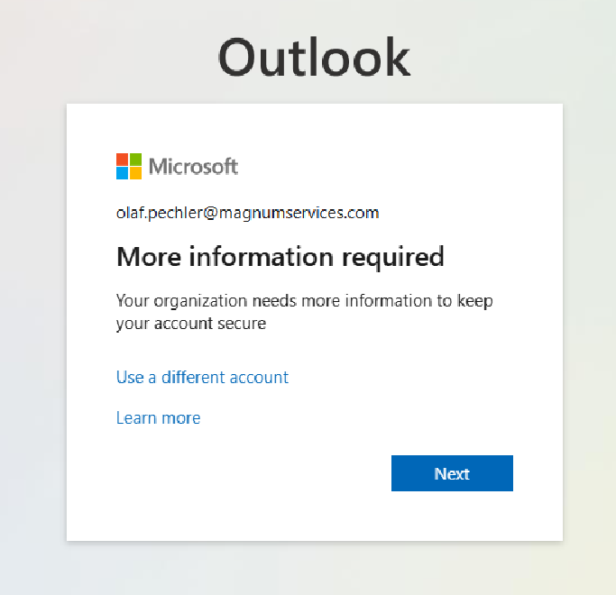Click “Next”.
2. A screenshot of a login account

   AI-generated content may be incorrect.Download the Microsoft Authenticator onto your phone from the Play Store or App Store. Once downloaded, click “Next”.
3. If prompted on your phone, allow notifications. Tap on the “+” button in the top right hand corner of the app.

1. Tap on “Work or school account” then tap on “Scan a QR code”.

1. A screenshot of a computer

   AI-generated content may be incorrect.Back on the computer click ”Next”.
2. Scan the QR code with your phone and click “Next” on the computer.

1. A hand holding a cell phone

   AI-generated content may be incorrect.A screenshot of a login box

   AI-generated content may be incorrect.Enter the 2 digit number into the pop up notification that shows up on your phone and click “Yes” on the phone. (You may be asked to enter your phone password, use Face ID, or fingerprint recognition)
2. A screenshot of a computer

   AI-generated content may be incorrect.Click “Next”.
3. Set the App Password name to “MagnumIT” and click “Next”. You are completely set up once you see the page below

**Please note that you will need to re-sign into your other devices to ensure you are still able to get emails and Teams calls/messages.**