1. A screenshot of a sign in

   Description automatically generatedGo to [Sign in to Concur | Concur Solutions](https://us2.concursolutions.com/nui/signin?targetURL=%2Fhome) and type in your Magnum email address as shown below, then click “Next”. (Typically [FirstName.LastName@magnumservices.com](mailto:FirstName.LastName@magnumservices.com))
2. A screenshot of a login page

   Description automatically generatedClick on “SAP Concur Password” and enter the temporary password that was provided to you, then click “Next”.

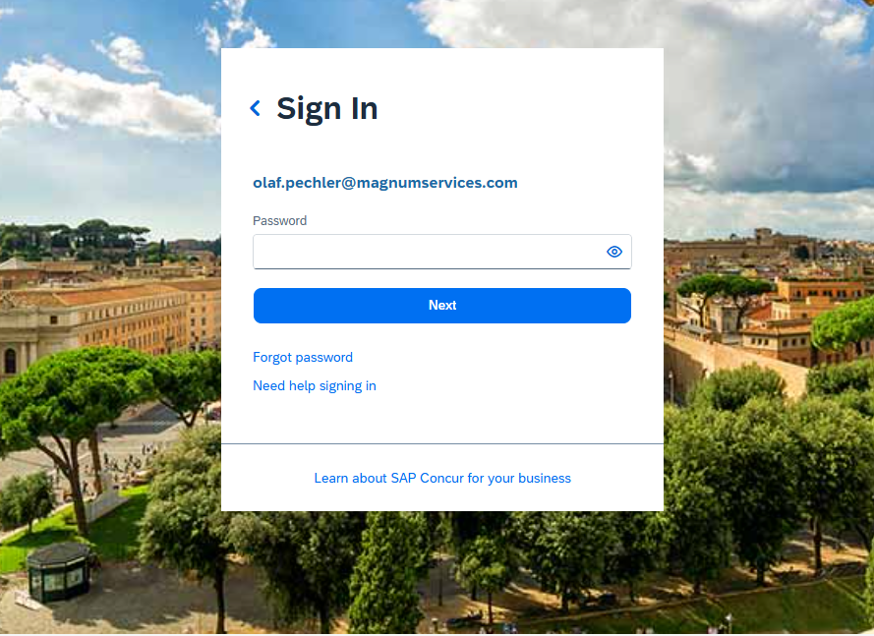

1. 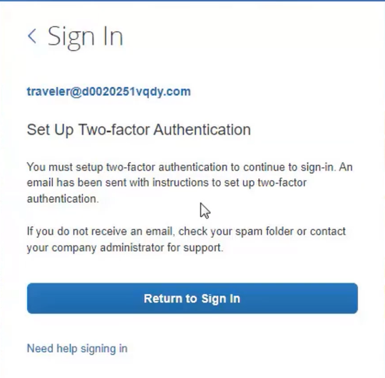After clicking “Next”, you should receive the message below. If you do, please go to your email and find an email similar to the second photo below.

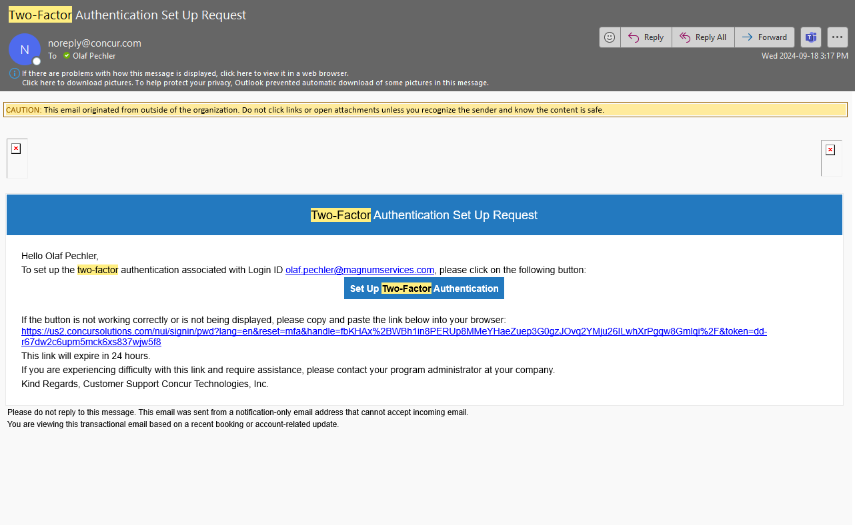

1. A screenshot of a login page

   Description automatically generatedClick on the link in the email. Download the Microsoft Authenticator onto your phone from the Play Store or App Store. Once downloaded, scan the QR code on the webpage.
2. Enter the 6 digit code from your phone into the website where it says “6-Digit Authentication Code” and click “Sign In”.