To create a meeting request, follow these simple steps.
- From your inbox select the New Email drop down menu (top left) choose Meeting.

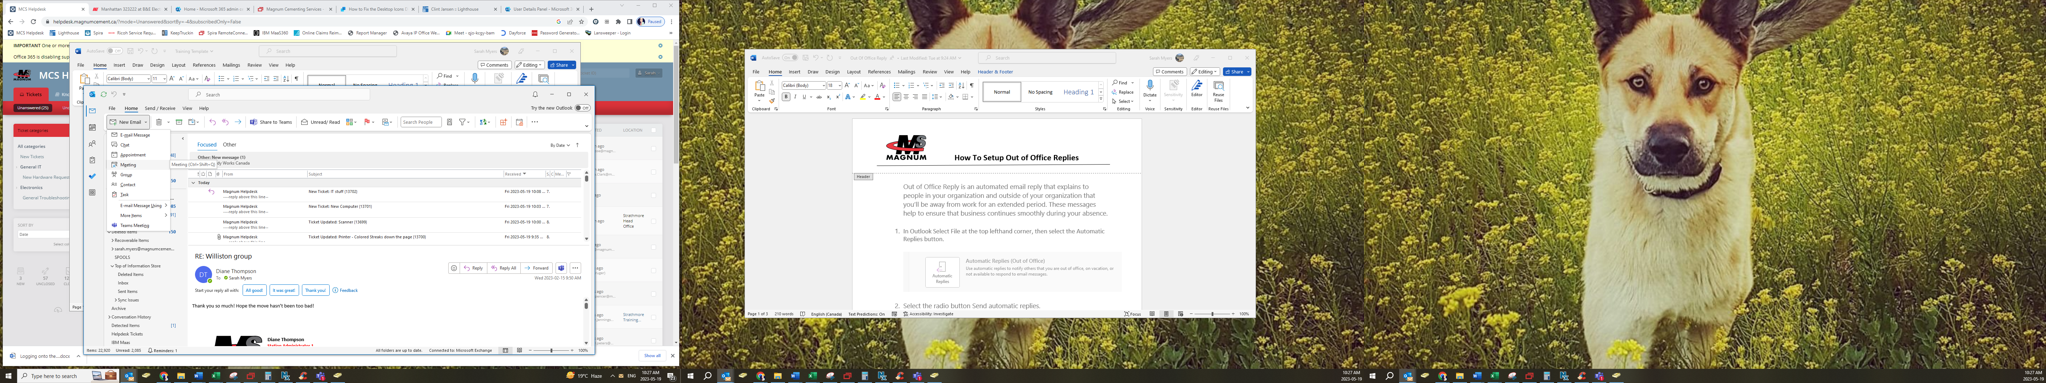
This will bring up your meeting details screen.
- Input the title of your Meeting.
- From here click on Scheduling Assistant to see your attendees schedules.
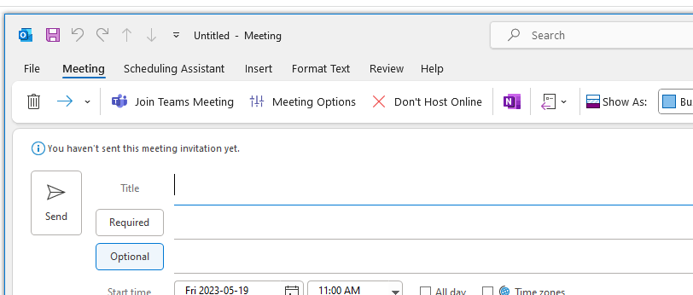
Input the title of your meeting.

- Type in your attendee’s name to view their calendar and availability.
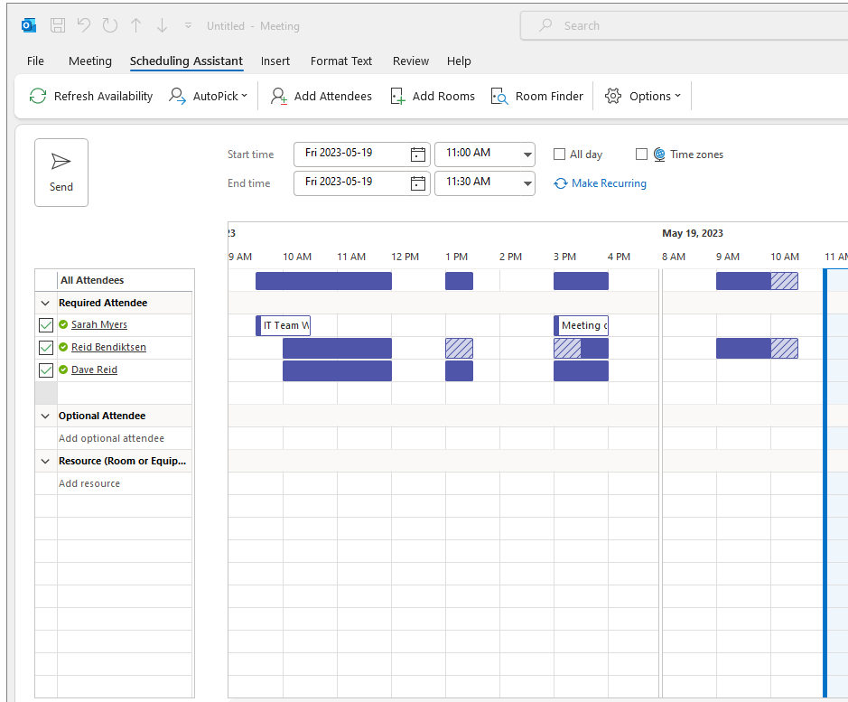
This displays the attendee’s schedule. Solid blocks indicate that the attendee is busy during the time noted above. The stripped blocks indicate they have a tentative meeting they haven’t accepted yet. The white blocks indicate that the attendee is available. This is a easy way to determine attendance to your meeting request.

- From this screen you can also select Add Rooms at the top to book a meeting room for your meeting. If this is to be a virtual meeting, then skip this step and go to step 7.

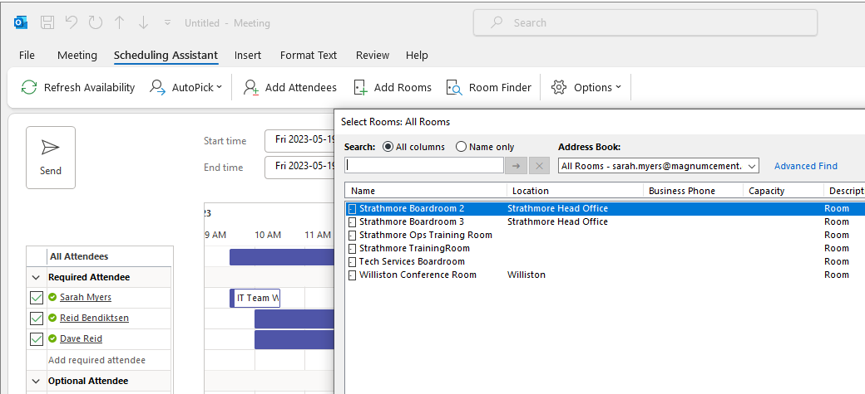

- If you do not see your boardroom listed alternatively you can search for the boardroom you would like to book by using the Address Book drop down menu, selecting Global Address List and typing in boardroom.

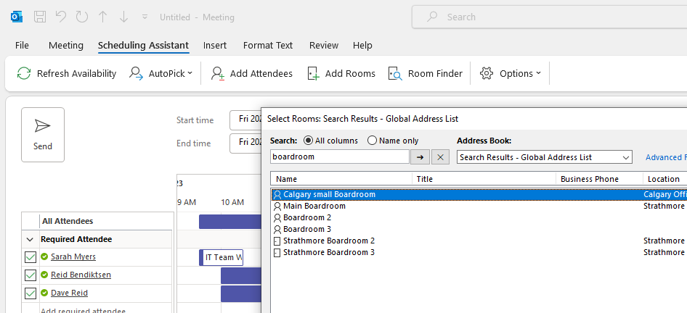
Use the drop-down menu to select Global Address List

- Now you are ready to select a day and time based on your attendee’s schedule. Once you have inputted that information you are ready to hit Send.

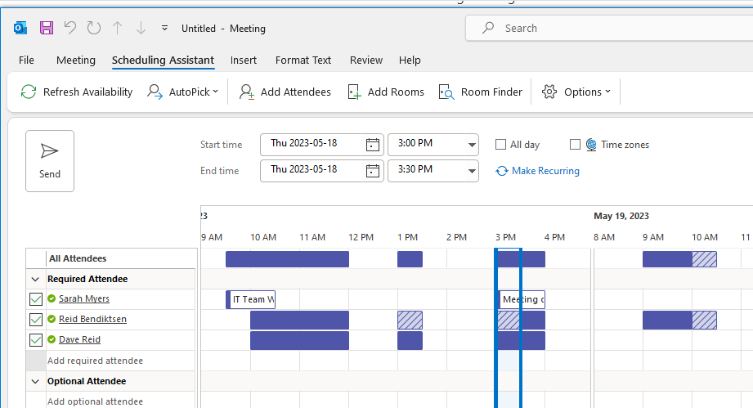
If your meeting is an all day event select the All day option.
If this is a meeting that will be happening every week or month select, make recurring and the Appointment Recurrence box will display giving you additional options.
Choose the day and time you would like to book your meeting depending on your attendee’s schedule.

