Out of Office Reply is an automated email reply that explains to people in your organization and outside of your organization that you’ll be away from work for an extended period. These messages help to ensure that business continues smoothly during your absence.

- In Outlook Select File at the top lefthand corner, then select the Automatic Replies button.

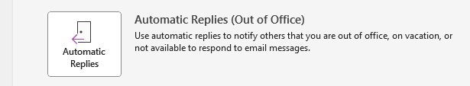

- Select the radio button Send automatic replies.

- If you know the date you will be returning to the office, then select the Only send during this time range. This will automatically turn off the notification when the end date arrives. If you do not know when you will be returning, then do not select this radio button.

- Compose your Out of Office message that people in and outside your organization will receive when they email you and then click on OK.
- 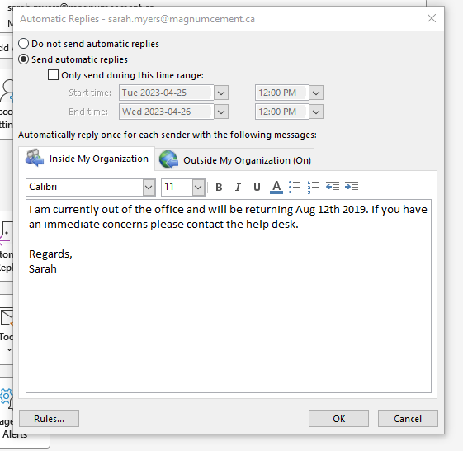
Type in your out of office message to people within your organization.
Select to send during this time range if you know a start and end date of your time away. Your automatic replies will turn off when the end date arrives.
Select to turn on automatic replies.

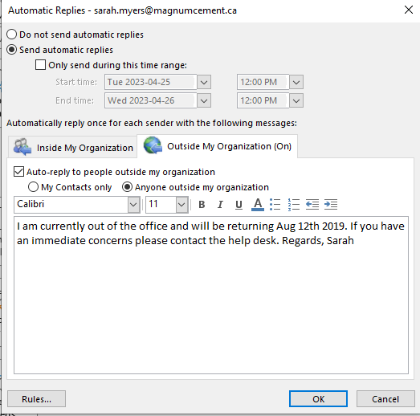
Select Outside of my Organization. Then type in your message for people to receive outside of your organization.

