To place a call on hold on one device and pick it up from another device, also known as parking a call, click More actions in your call window and select Call park .

After you park the call, Teams will give you a unique code you can use to retrieve the call. If someone else is retrieving the call, copy the code and share it with them.

To retrieve a parked call, go to the Calls tab, click Parked Calls, and enter the park code.

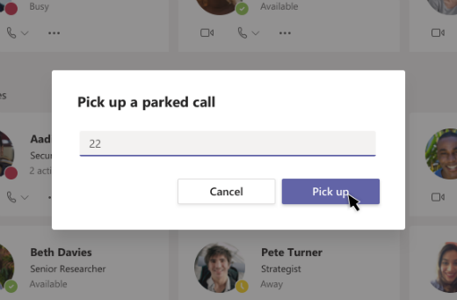

If no one picks up a parked call within 5 minutes, it’ll ring again.

