Setup Magnum App Server (Dynamics)

Note - You can always access the web portal for the apps at <http://apps.mcs.magnumcement.ca>

* Go Start –> Control Panel
* Make sure view by “Small Icons” is selected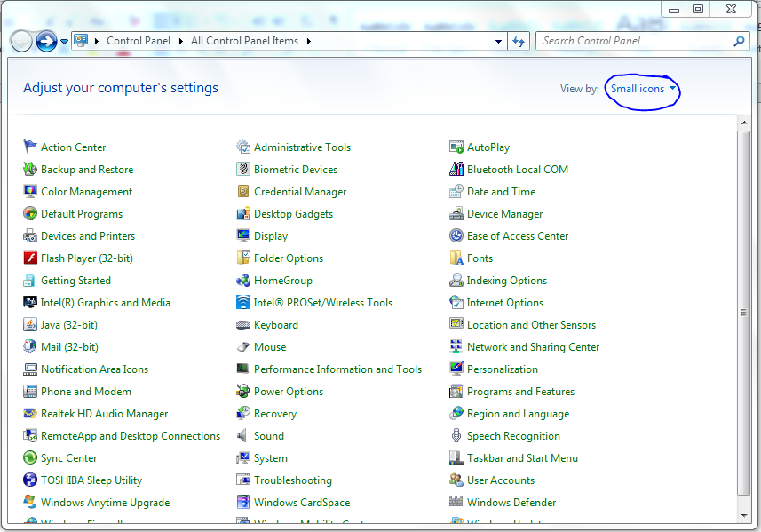
* Click on the RemoteApp and Desktop Connections

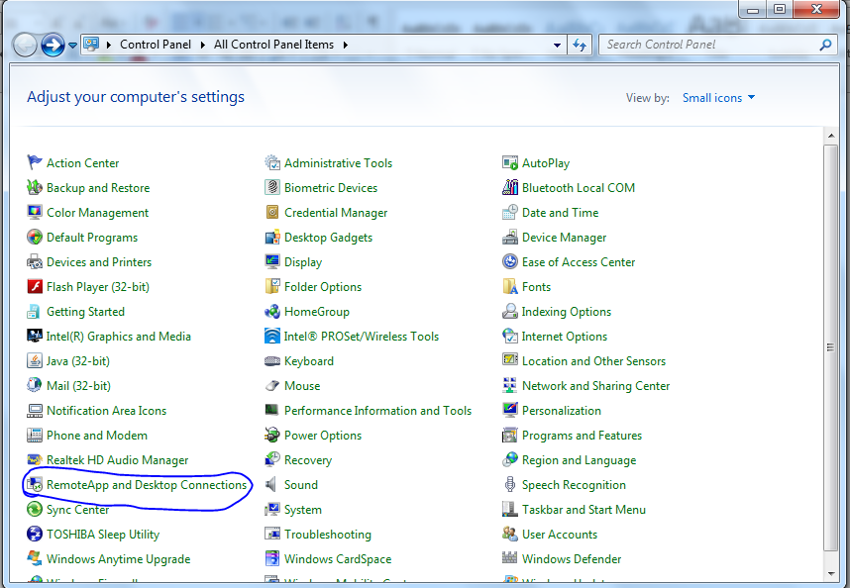

* Click on setup a “new connection..” in the left had side  
  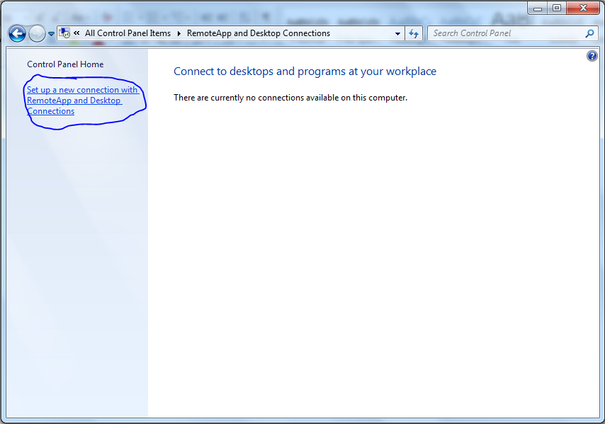
* When prompted for a connection URL enter:  
  <https://apps.mcs.magnumcement.ca/RDWeb/Feed/webfeed.aspx>
* Click on “Next” at the connection prompt  
  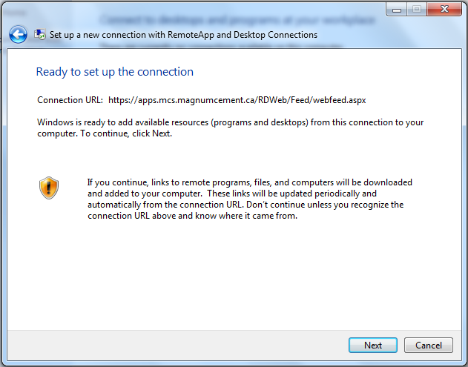
* When prompted enter your domain username and password. Domain usernames are the MCS\<firstname>.<lastname> ones
* You will be prompted the connection has been setup  
  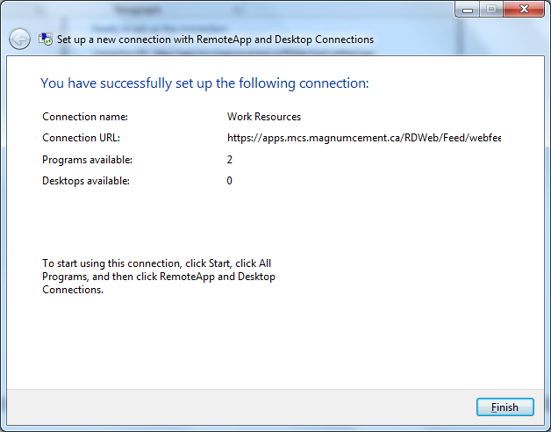
* Under the Start menu there will now be a remoteapp and desktop connections folders with the links to the apps you have permission to. You can use that link to connect directly without having to go through the web portal.  
  