How to create a new Apple ID on your iPhone or iPad

(Guide originally written by Lory Gil, modified for Magnum Cement)

1. Open the **Settings app**.
2. Tap **iCloud**.
3. Tap **Create a new Apple ID**.

[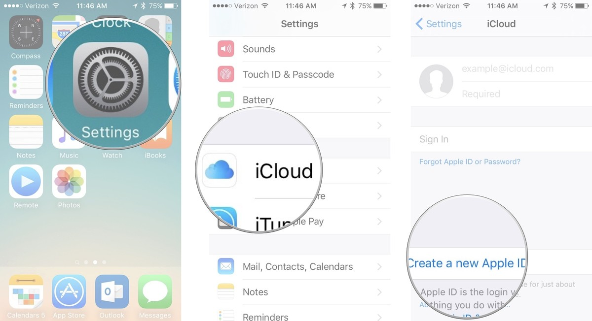](https://www.imore.com/sites/imore.com/files/styles/xlarge/public/field/image/2016/05/Create-new-Apple-ID-Settings-iCloud-iPhone-screenshot.jpg?itok=MdkaToDj)

1. Enter a **birth date**.
2. Tap **Next**.
3. Enter your **first and last name**.
4. Tap **Next**.
5. Select Create a new apple ID

[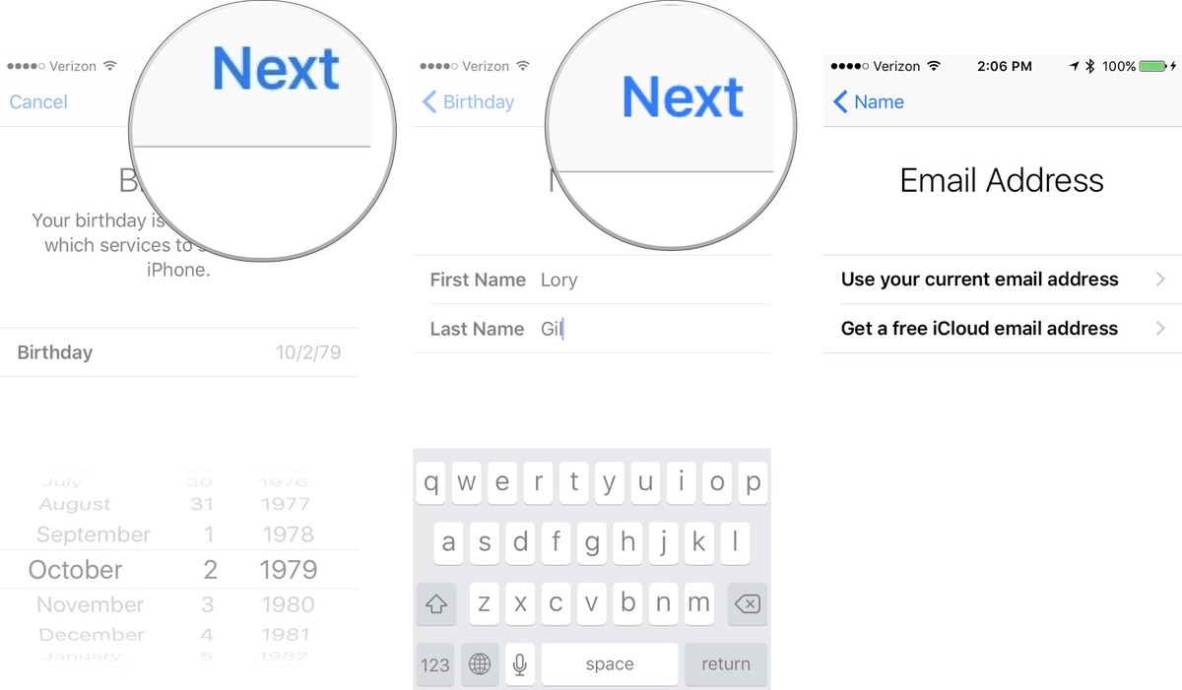](https://www.imore.com/sites/imore.com/files/styles/xlarge/public/field/image/2016/05/Create-new-Apple-ID-birthday-name-email-iPhone-screenshot.jpg?itok=eUScHI83)

1. Enter your Company **email address**.
2. Create a **password**.
3. Verify the **password**.
4. Select a **security question**.
5. Type in **answer**.
6. Repeat two more times.

[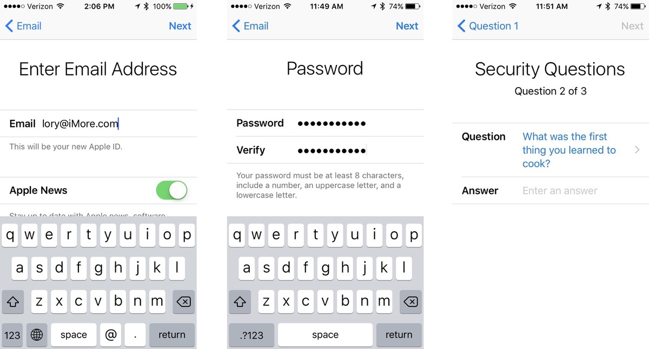](https://www.imore.com/sites/imore.com/files/styles/xlarge/public/field/image/2016/05/Create-new-Apple-ID-security-question-iPhone-screenshot.jpg?itok=QJMZfqE-)

1. Agree to the **Terms and Conditions**.
2. Tap **Merge** or **Don't Merge** to sync iCloud data from Safari, reminders, contacts and calendars.
3. Tap **OK** to confirm Find My iPhone is turned on.

[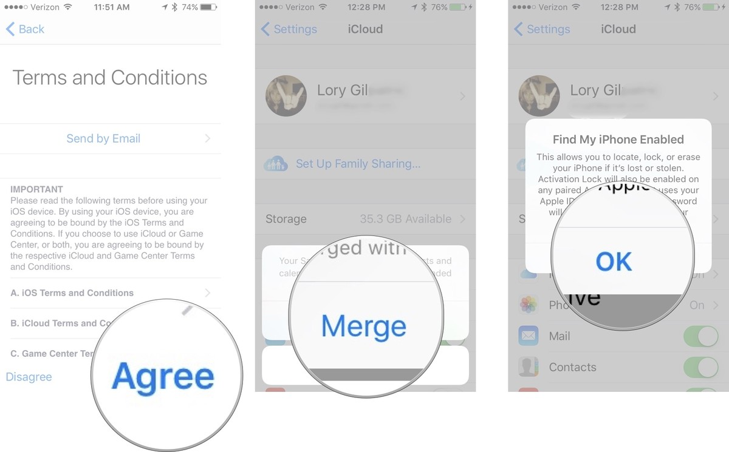](https://www.imore.com/sites/imore.com/files/styles/xlarge/public/field/image/2016/05/Create-new-Apple-ID-TC-merge-Find-My-iPhone-screenshot.jpg?itok=eohnAqXt)